# HUMAN RESOURCE ANALYTICS DASHBOARD

**USING TABLEAU**

### A Micro Project Report

#### Submitted by

**GRANDHI V RAMA AMARA LAKSHMI MANIKANTA 99220041482**

### B.Tech – Computer Science and Engineering, Cyber Security



**Kalasalingam Academy of Research and Education**

**(Deemed to be University) Anand Nagar, Krishnankoil - 626 126**

### March 2024



**SCHOOL OF COMPUTING**

**DEPARTMENT OF COMPUTER SCIENCE AND ENGINEERING**

# BONAFIDE CERTIFICATE

Bonafide record of the work done by G R A N D H I V R A M A A M A R A L A K S H M I M A N I K A N T A - 99220041482 in partial fulfillment of the requirements for the award of the degree of Bachelor of Technology in Specialization of the Computer Science and Engineering, during the Academic Year Even Semester (2023-24)

**Dr. N.Subbu Lakshmi Mr.B.Sakthi Karthi Durai**

**Project Guide Faculty Incharge**

**Associate professor Assistant professor**

**Computer Science and Engineering Computer Science and Engineering**

**Kalasalingam Academy of Kalasalingam Academy of**

**Research and Education Research and Education**

**Krishnan kovil - 626126 Krishnan kovil - 626126**

**Dr.P.VelMurga Dass Evaluator**

**Assistant professor**

**Computer Science and Engineering Kalasalingam Academy of Research and Education**

**Krishnan kovil - 626126**

# Abstract

In the realm of human resources management, effective decision-making relies heavily on insightful analytics. This project introduces an HR Analytics Dashboard leveraging Tableau, offering a comprehensive overview of vital workforce metrics. The dashboard encapsulates key indicators including employee count, attrition statistics, and attrition rates, providing real-time insights into workforce dynamics. Additionally, it furnishes detailed breakdowns such as department-wise attrition, distribution of employees across age groups, job satisfaction ratings, and attrition patterns across gender and education fields. By amalgamating data visualization with advanced analytics, this dashboard empowers HR professionals to make data-driven decisions, optimize retention strategies, and enhance organizational performance.

# Contents

1. Introduction 1
   1. Purpose of the HR Analytics Dashboard 1
   2. Scope of the Project 1
      1. Data Collection and Analysis 1
      2. Dashboard Design and Implementation 2
2. Understanding Workforce Dynamics **3**
   1. Employee Count 3
      1. Total Employee Count Analysis 4
   2. Attrition Count and Rate 4
      1. Department-wise Attrition 4
      2. Attrition Rate by Gender for Different Age Groups 5
   3. Active Employees Analysis 6
      1. Employee Engagement and Retention 6
3. Employee Satisfaction and Retention Strategies **7**
   1. Job Satisfaction Rating 7
      1. Employee Survey Analysis 7
      2. Comparison and Benchmarking 9
   2. Education Field-wise Attrition 11
4. Conclusion and Future Work 12
   1. Summary of Findings 12
   2. Recommendations for HR Decision-making 12

CONTENTS CONTENTS

1. References 13
2. Certification 14

**List of Figures**

|  |  |  |  |
| --- | --- | --- | --- |
| 1.1 | HR Analytics Dashboard | . . . . . . . . . . . . . . . . . | 2 |
| 2.1 | Employee Count | . . . . . . . . . . . . . . . . . | 3 |
| 2.2 | Attrition Rate by Gender for different Age Groups | . . . . . . . . . . . . . . . . . | 6 |
| 3.1 | No of Employee by Age Group | . . . . . . . . . . . . . . . . . | 9 |
| 3.2 | Department wise Attrition | . . . . . . . . . . . . . . . . . | 9 |
| 6.1 | Certification details | . . . . . . . . . . . . . . . . . | 14 |

**Chapter 1**

# Introduction

### Purpose of the HR Analytics Dashboard

### Scope of the Project

The purpose of the HR Analytics Dashboard is to provide actionable insights into various aspects of the organization's workforce. By leveraging data analytics, the dashboard aims to enable informed decision- making, identify trends and patterns, optimize HR strategies, and support proactive measures. In essence, it serves as a powerful tool for HR professionals to understand, analyze, and optimize various aspects of the workforce, ultimately contributing to the organization's success and sustainability.

#### Data Collection and Analysis

* + - 1. Data collection for this project was conducted using Kaggle, a renowned platform for datasets and data science resources. The dataset chosen for analysis encapsulates a comprehensive array of information pertinent to the organization's workforce dynamics.
      2. The dataset sourced from Kaggle contains detailed records encompassing employee demographics, job roles, satisfaction metrics, and attrition rates. This single dataset serves as the primary source for analysis, providing a rich repository of variables essential for comprehensive workforce assessment and insights generation.
      3. The careful selection of this dataset ensures the availability of relevant data points crucial for robust analysis, enabling a thorough examination of workforce trends, patterns, and correlations.

1.2. Scope of the Project Chapter 1. Introduction

#### Dashboard Design and Implementation

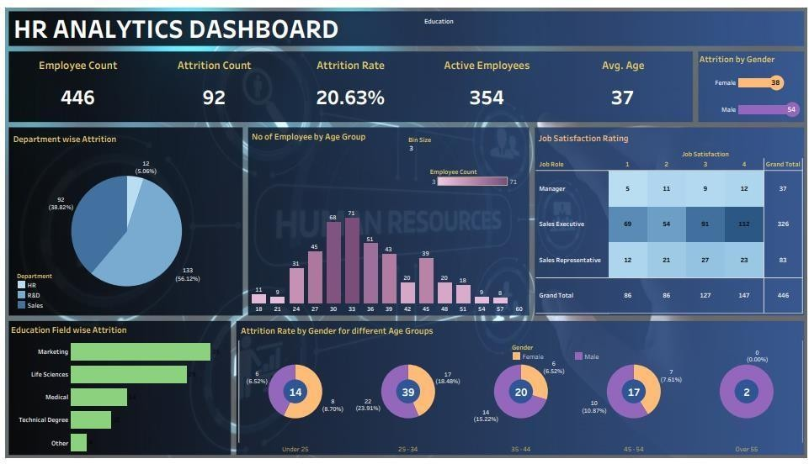

Figure 1.1: HR Analytics Dashboard

The dashboard's design prioritized clarity and accessibility, ensuring that users can easily navigate through various sections and comprehend the presented insights effectively. Additionally, the implementation phase focused on integrating interactive elements and intuitive visualizations to enhance user engagement and facilitate deeper exploration of workforce data.

Overall, the design and implementation of the HR Analytics Dashboard aimed to provide HR professionals with a powerful tool for data-driven decision-making and strategic workforce management.

**Chapter 2**

Understanding Workforce Dynamics

### 2.1 Employee Count

The analysis of employee count is fundamental to understanding the workforce composition within the organization. It provides insights into the size and scale of the workforce, serving as a foundational metric for various HR initiatives and strategic planning efforts. By examining employee count data over time and across different departments or demographics, organizations can identify trends, anticipate staffing needs, and optimize resource allocation to support their business objectives effectively. Additionally, understanding fluctuations in employee count can help HR professionals assess the impact of recruitment efforts, retention strategies, and organizational changes on the overall workforce composition.

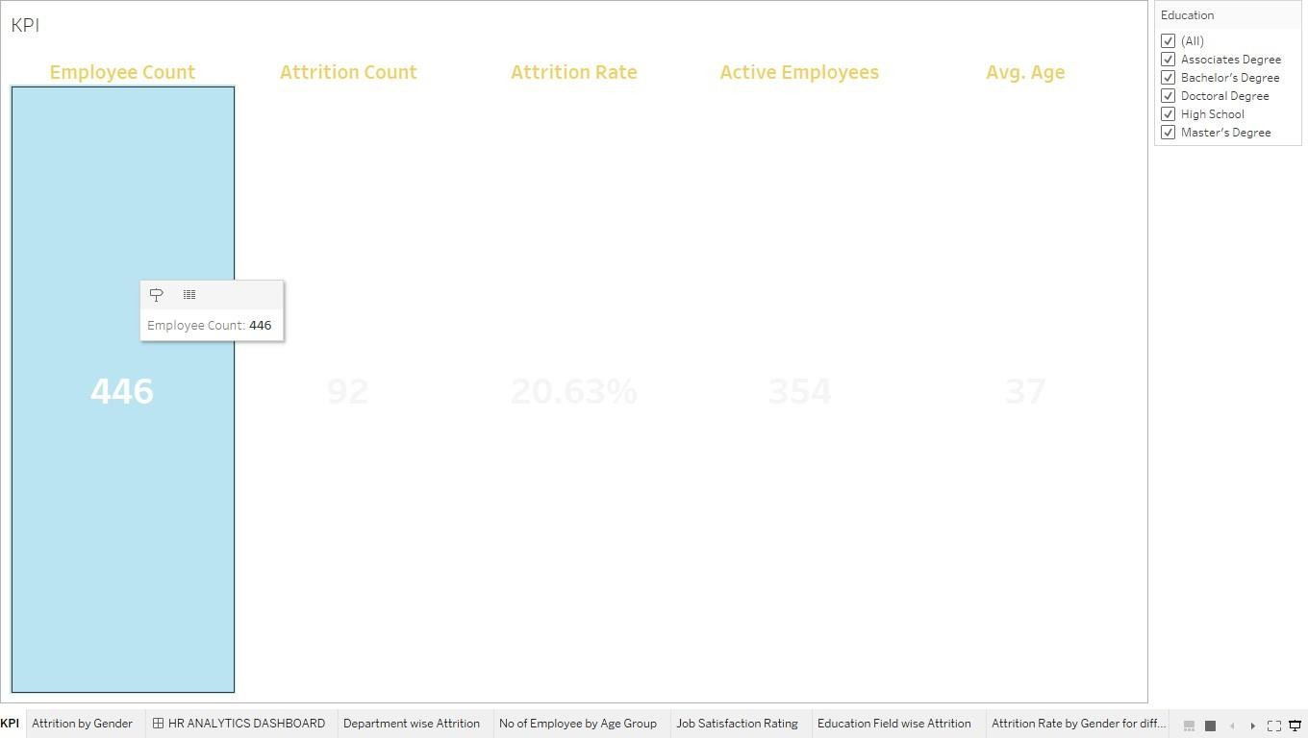

Figure 2.1: Employee Count

* 1. Employee Count Chapter 2. Understanding Workforce Dynamics

#### Total Employee Count Analysis

The total employee count analysis is a critical component of workforce management, providing essential insights into the organization's human capital. Currently, the organization boasts a robust workforce with a total employee count of 446. By examining this figure, HR professionals can gauge the organization's size and scale, tracking changes over time to identify patterns that may impact operations. Understanding fluctuations in employee count is pivotal; it informs strategic decision-making related to recruitment, staffing levels, and resource allocation. Moreover, analyzing employee count data in conjunction with other metrics such as attrition rates and departmental demographics provides a holistic view of the workforce. This comprehensive understanding enables organizations to develop targeted initiatives to support employee engagement, retention, and overall organizational success.

### Attrition Count and Rate

* The attrition count within the organization currently stands at 92 employees. This count signifies the number of individuals who have left the organization within a specified period.
* The attrition rate, calculated at 20.63%, indicates the proportion of employees who have departed relative to the total workforce.
* This analysis of attrition count and rate provides valuable insights into workforce dynamics, aiding HR professionals in understanding and addressing employee turnover within the organization.

#### Department-wise Attrition

Department-wise attrition analysis reveals significant variations in turnover rates across different departments within the organization.

* In the HR department, the attrition rate is recorded at 5.06%.
* In the R&D department, the attrition rate is notably higher at 56.12%.
* Conversely, the Sales department experiences a comparatively lower attrition rate of 38.82%.

Understanding department-wise attrition rates is crucial for HR professionals to identify areas of concern and implement targeted retention strategies to mitigate turnover and maintain organizational stability.

* 1. Attrition Count and Rate Chapter 2. Understanding Workforce Dynamics

#### Attrition Rate by Gender for Different Age Groups

* Examining attrition rates by gender across various age groups provides valuable insights into workforce dynamics and retention strategies.
* In the under 25 age group, the attrition rate is comparatively higher among females, standing at 8.70%, while males exhibit a slightly lower attrition rate of 6.52%. This suggests potential differences in factors influencing turnover among younger employees based on gender.
* Within the 25-34 age bracket, females experience a higher attrition rate of 18.48% compared to males at 23.91%. This disparity may stem from distinct career aspirations, work-life balance preferences, or organizational support mechanisms.
* Moving to the 35-44 age group, the attrition rate among females decreases to 6.52%, whereas males demonstrate a higher attrition rate of 15.22%. This divergence may reflect shifting priorities or career advancement opportunities among different genders within this age range.
* Similarly, in the 45-54 age group, females exhibit a lower attrition rate of 7.61% compared to males at 10.87%. This discrepancy may arise from factors such as job satisfaction, career stability, or retirement plans.
* Analyzing attrition rates through the intersection of gender and age groups enables HR professionals to pinpoint areas of vulnerability and tailor retention strategies accordingly. By addressing the unique needs and concerns of different demographic segments, organizations can foster a more inclusive and supportive workplace culture, ultimately enhancing employee engagement and organizational resilience.
* Analyzing attrition rates through the intersection of gender and age groups enables HR professionals to pinpoint areas of vulnerability and tailor retention strategies accordingly. By addressing the unique needs and concerns of different demographic segments, organizations can foster a more inclusive and supportive workplace culture, ultimately enhancing employee engagement and organizational resilience.
  1. Active Employees Analysis Chapter 2. Understanding Workforce Dynamics

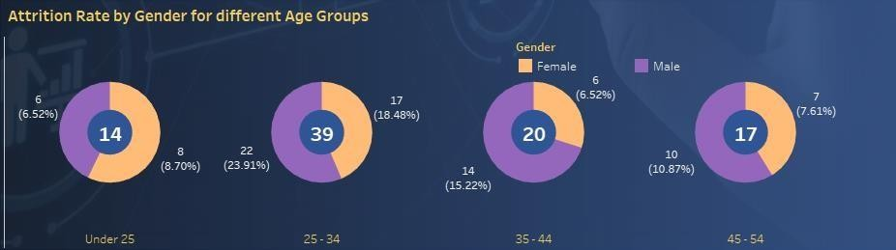

Figure 2.2: Attrition Rate by Gender for different Age Groups

### Active Employees Analysis

The analysis of active employees is paramount in assessing workforce stability and organizational performance. It provides crucial insights into the number of employees currently engaged in organizational activities, contributing to productivity and overall effectiveness.

This comprehensive analysis forms the foundation for strategic workforce planning, enabling organizations to align staffing levels with business objectives and effectively manage human capital resources.

#### Employee Engagement and Retention

The analysis of employee engagement and retention is vital for organizations aiming to maintain a motivated and committed workforce. By evaluating factors such as job satisfaction, organizational culture, and career development opportunities, HR professionals can identify areas of strength and areas for improvement in employee engagement and retention strategies. Understanding the drivers of employee engagement and retention enables organizations to implement targeted initiatives to foster a positive work environment, increase employee satisfaction, and reduce turnover rates.

**Chapter 3**

## Employee Satisfaction and Retention Strategies

### Job Satisfaction Rating

Employee satisfaction is a cornerstone of organizational success, impacting productivity, morale, and retention rates. By evaluating job satisfaction ratings across different roles, organizations can identify areas of strength and areas for improvement in their employee experience.

Manager: 37

Sales Executive: 326

Sales Representative: 83

Understanding job satisfaction ratings allows organizations to tailor retention strategies to address specific concerns and preferences of employees in different roles. By focusing on enhancing job satisfaction, organizations can create a more positive work environment, increase employee engagement, and reduce turnover rates.

#### Employee Survey Analysis

##### Employee Engagement Insights

Employee survey analysis delves into the depth of employee engagement, providing valuable insights into factors that influence morale and productivity.

* 1. Employee Survey Analysis Chapter 3. Employee Satisfaction and Retention Strategies

##### Key Findings:

* + - 68% of employees expressed satisfaction with their current role and responsibilities.
    - 42% of employees indicated a desire for additional training and development opportunities. 55% of employees highlighted the importance of transparent communication from leadership.
    - Understanding these insights enables organizations to tailor employee engagement strategies effectively, fostering a culture of trust, collaboration, and continuous improvement.

##### Retention Strategy Recommendations

Employee survey analysis also informs retention strategy development, guiding organizations in identifying retention challenges and implementing targeted interventions to mitigate turnover. By examining survey data, organizations can pinpoint areas of dissatisfaction and develop strategies to enhance employee satisfaction and loyalty.

##### Recommendations:

* Implement mentorship programs to support employee growth and development.
* Enhance communication channels to facilitate transparent dialogue between management and employees.
* Offer competitive compensation and benefits packages to incentivize employee retention. Implementing these retention strategy recommendations strengthens organizational resilience, reduces turnover rates, and fosters a workplace environment conducive to employee satisfaction and long-term success.

3.1 Employee Survey Analysis Chapter 3. Employee Satisfaction and Retention Strategies

#### Comparison and Benchmarking

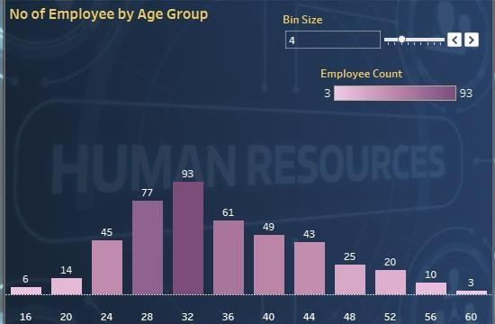

Figure 3.1: No of Employee by Age Group

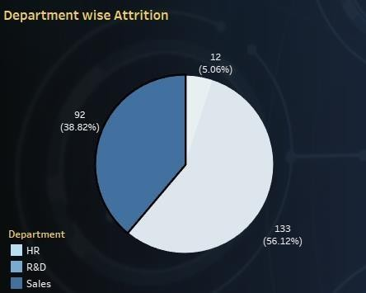

Figure 3.2: Department wise Attrition

* 1. Employee Survey Analysis Chapter 3. Employee Satisfaction and Retention Strategies

##### Number of Employees by Age Group:

Analyzing the number of employees by age group provides valuable insights into the demographic composition of the workforce. By categorizing employees into different age brackets, organizations can identify trends, such as workforce aging or generational shifts, that may impact strategic planning and talent management initiatives. This analysis enables HR professionals to develop targeted recruitment strategies, succession planning efforts, and training programs tailored to the specific needs and preferences of different age groups within the organization. Additionally, understanding the distribution of employees across age groups allows organizations to address potential challenges related to knowledge transfer, succession planning, and workforce diversity, ensuring a balanced and sustainable talent pipeline for future growth and success.

##### Department-Wise Attrition:

Department-wise attrition analysis provides critical insights into turnover patterns across different functional areas within the organization. By examining attrition rates by department, HR professionals can identify areas of concern and potential risk factors contributing to employee departures. This analysis enables organizations to pinpoint departments with high attrition rates and investigate underlying issues such as poor leadership, lack of career advancement opportunities, or job dissatisfaction. Armed with this information, organizations can develop targeted retention strategies, including mentorship programs, career development initiatives, and performance management interventions, to mitigate turnover and enhance employee engagement and satisfaction. Additionally, department-wise attrition analysis facilitates benchmarking efforts, allowing organizations to compare turnover rates across departments and industry norms, identifying areas for improvement and best practices to optimize workforce management strategies.

* 1. Education Field-wise Attrition Chapter 3. Employee Satisfaction and Retention Strategies

### 3.2 Education Field-wise Attrition

Education field-wise attrition analysis offers valuable insights into the turnover trends among employees based on their educational backgrounds. By categorizing employees according to their fields of study, organizations can identify potential correlations between education and attrition rates, allowing for targeted interventions and retention strategies.

**Marketing:** With an attrition count of 35, employees with a background in marketing demonstrate a notable turnover rate. This could be attributed to various factors such as high demand for marketing professionals in competitive industries or career mobility within the field.

**Life Sciences:** Employees with a background in life sciences experience a moderate attrition count of

29. This field often involves specialized roles with opportunities for career advancement and lateral moves, which may contribute to turnover as employees seek new challenges.

**Medical:** The attrition count for employees with a medical background is relatively lower at 14. Careers in the medical field often require extensive education and training, leading to a more stable workforce with lower turnover rates.

**Technical Degree:** Employees with technical degrees exhibit a modest attrition count of 10. Technical roles often offer strong job security and opportunities for skill development, leading to lower turnover rates compared to other fields.

**Other:** Employees categorized under "other" fields demonstrate the lowest attrition count at 4. This category may include employees with diverse educational backgrounds outside of the specified categories, contributing to a smaller attrition rate.

Understanding education field-wise attrition patterns allows organizations to tailor recruitment strategies, training programs, and career development initiatives to address the unique needs and preferences of employees from different educational backgrounds, ultimately enhancing retention and organizational performance.

**Chapter 4**

# Conclusion and Future Work

### Summary of Findings

The summary of findings encapsulates the key insights derived from the comprehensive analysis conducted. It serves as a synthesis of the data and observations gathered throughout the research process, providing stakeholders with a clear understanding of the implications and recommendations derived from the study.

The summary provides a concise overview of the main findings, highlighting significant trends, patterns, and implications identified during the analysis. It serves as a valuable tool for decision- makers, enabling them to make informed choices and take strategic actions based on the insights gleaned from the research.

### Recommendations for HR Decision-making

Incorporating data-driven recommendations into HR decision-making processes is essential for fostering a proactive and strategic approach to human resource management. By leveraging insights gained from thorough analysis, organizations can optimize their HR strategies to enhance employee engagement, retention, and overall organizational performance.

**Chapter 5**

# References

* + 1. [Human Resources Dashboards (tableau.com)](https://www.tableau.com/solutions/human-resources-analytics/dashboards)
    2. [Tableau HR Dashboard: Insights at a Glance | by Kalaikc16 | Feb, 2024 | Medium](https://medium.com/%40kalaikc84/tableau-hr-dashboard-insights-at-a-glance-ae8916f1d16d)
    3. [GitHub - ssati19/HR-Analytics-Tableau-Dashboard-: The HR Analytics Dashboard project using](https://github.com/ssati19/HR-Analytics-Tableau-Dashboard-) [Tableau is designed to provide insights into key metrics and trends related to human resource](https://github.com/ssati19/HR-Analytics-Tableau-Dashboard-) [management in an organization. The dashboard utilizes visualizations and data analysis](https://github.com/ssati19/HR-Analytics-Tableau-Dashboard-) [techniques to help HR professionals identify patterns and make data-driven decisions.](https://github.com/ssati19/HR-Analytics-Tableau-Dashboard-)
    4. [(11) HR Analytics Dashboard Using Tableau and SQL Queries - A Complete End-to-End Project](https://www.linkedin.com/pulse/hr-analytics-dashboard-using-tableau-sql-queries-complete-patel-b9zpf/) [Guide [ With Datasets ] | LinkedIn](https://www.linkedin.com/pulse/hr-analytics-dashboard-using-tableau-sql-queries-complete-patel-b9zpf/)
    5. [HR Dashboard: 7 Key Examples and Best Practices | Qlik](https://www.qlik.com/us/dashboard-examples/hr-dashboard)

**Chapter 6**

# Certification

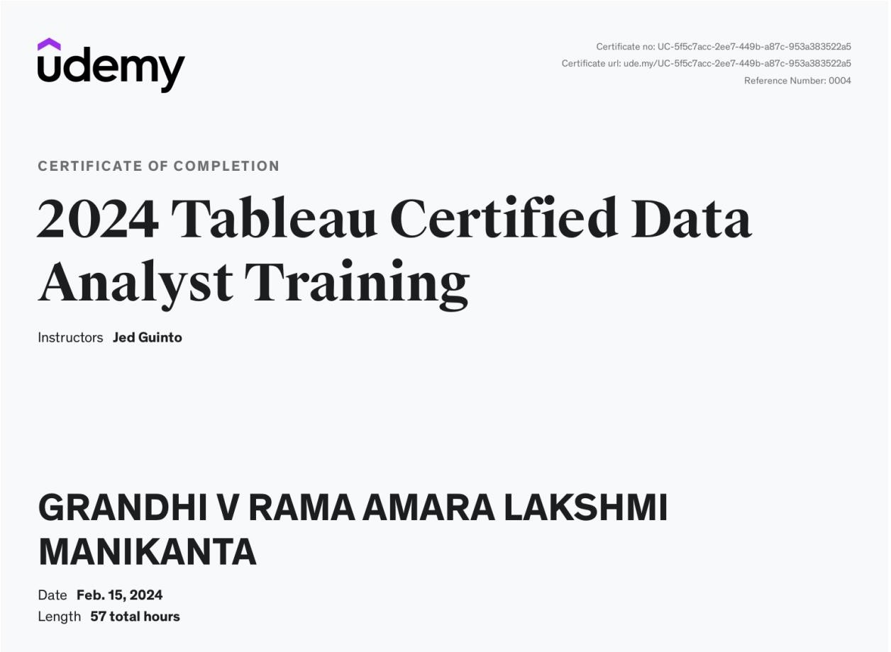

Figure 6.1: Certification details